Chapter 6: Plant Nutrition
Plant nutrition is primarily concerned with how plants obtain and utilize nutrients for growth and survival. The most fundamental process in plant nutrition is photosynthesis, through which plants produce their own food.

6.1 Photosynthesis

Definition and Word Equation
Photosynthesis is the process by which green plants and some other organisms use sunlight to synthesize foods with the help of chlorophyll. This process converts light energy into chemical energy, which is stored in glucose.

The word equation for photosynthesis is:

Carbon dioxide + Water → Glucose + Oxygen

This reaction occurs in the presence of light and chlorophyll.

Balanced Chemical Equation (Supplement)
For a more detailed understanding, the balanced chemical equation for photosynthesis is:

6CO₂ + 6H₂O → C₆H₁₂O₆ + 6O₂

Role of Chlorophyll
- Chlorophyll is a green pigment found in the chloroplasts of plant cells.
- Its primary role is to transfer energy from light into chemical energy, which is then used for the synthesis of carbohydrates (glucose).

Subsequent Use and Storage of Carbohydrates
The glucose produced during photosynthesis is a vital energy source and building block for plants. It can be used or stored in several ways:

- Starch: Glucose is converted into starch for long-term energy storage. Starch is insoluble, making it an ideal storage molecule as it does not affect the water potential of the cell.
- Cellulose: Glucose is used to synthesize cellulose, which is a major structural component of plant cell walls, providing support and rigidity to the plant.
- Respiration: Glucose is used in respiration to release energy for various metabolic processes in the plant, such as growth, active transport, and maintenance.
- Sucrose: Glucose can be converted into sucrose for transport in the phloem to other parts of the plant where it is needed for energy or storage.
- Nectar: In some plants, glucose is used to produce nectar, a sugary liquid that attracts insects and other animals for pollination.

Importance of Mineral Ions
Plants also require various mineral ions from the soil for healthy growth and to synthesize essential molecules:

- Nitrate ions (NO₃⁻): Essential for making amino acids, which are the building blocks of proteins. Proteins are crucial for enzymes, structural components, and many other cellular functions. Without sufficient nitrate, plants cannot produce enough proteins, leading to stunted growth.
- Magnesium ions (Mg²⁺): A key component of chlorophyll. Without sufficient magnesium, plants cannot produce enough chlorophyll, leading to chlorosis (yellowing of leaves) and reduced photosynthesis.

Investigating Photosynthesis
Experiments can be conducted to investigate the factors necessary for photosynthesis:

- Need for Chlorophyll: By using variegated leaves (leaves with green and white patches), one can demonstrate that only the green parts (containing chlorophyll) photosynthesize.
- Need for Light: Covering a part of a leaf with aluminum foil or placing a plant in darkness for a period can show that light is essential for starch production (a product of photosynthesis). OR Using lamp and varying its distance from the plant (pond weed) and count number of bubbles released
- Need for Carbon Dioxide: Using a plant in a sealed container with a carbon dioxide absorber (e.g., soda lime) can demonstrate that carbon dioxide is necessary for photosynthesis.

Effects of Varying Environmental Conditions on Photosynthesis Rate
The rate of photosynthesis is affected by several environmental factors:

- Light Intensity: As light intensity increases, the rate of photosynthesis generally increases up to a certain point, after which it plateaus (becomes a limiting factor).
- Carbon Dioxide Concentration: An increase in carbon dioxide concentration generally increases the rate of photosynthesis, up to a point where other factors become limiting.
- Temperature: Photosynthesis is an enzyme-controlled process, so its rate increases with temperature up to an optimum, after which it decreases rapidly due to enzyme denaturation.

Limiting Factors of Photosynthesis (Supplement)
A limiting factor is a factor that restricts the rate of a process when it is in short supply. For photosynthesis, the main limiting factors are:

- Light intensity: At low light levels, increasing light intensity will increase the rate of photosynthesis.
- Carbon dioxide concentration: At low CO₂ levels, increasing CO₂ concentration will increase the rate of photosynthesis.
- Temperature: At sub-optimal temperatures, increasing temperature will increase the rate of photosynthesis. At very high temperatures, enzymes denature, and the rate decreases.

Gas Exchange in Aquatic Plants (Supplement)
Hydrogencarbonate indicator solution can be used to investigate gas exchange in aquatic plants. The indicator changes color based on the pH, which is affected by the concentration of carbon dioxide:

- In light: Photosynthesis occurs, consuming CO₂. This increases the pH, turning the indicator solution purple.
- In dark: Photosynthesis stops, but respiration continues, producing CO₂. This decreases the pH, turning the indicator solution yellow.

6.2 Leaf Structure

Leaf features
- Large Surface Area: This provides a greater area to absorb as much sunlight as possible, which is the energy source for photosynthesis.
- Thinness: This reduces the distance that carbon dioxide (CO₂) has to diffuse from the stomata into the cells, and that oxygen (O₂) has to diffuse out. It also allows light to penetrate more easily to the cells deeper in the leaf.

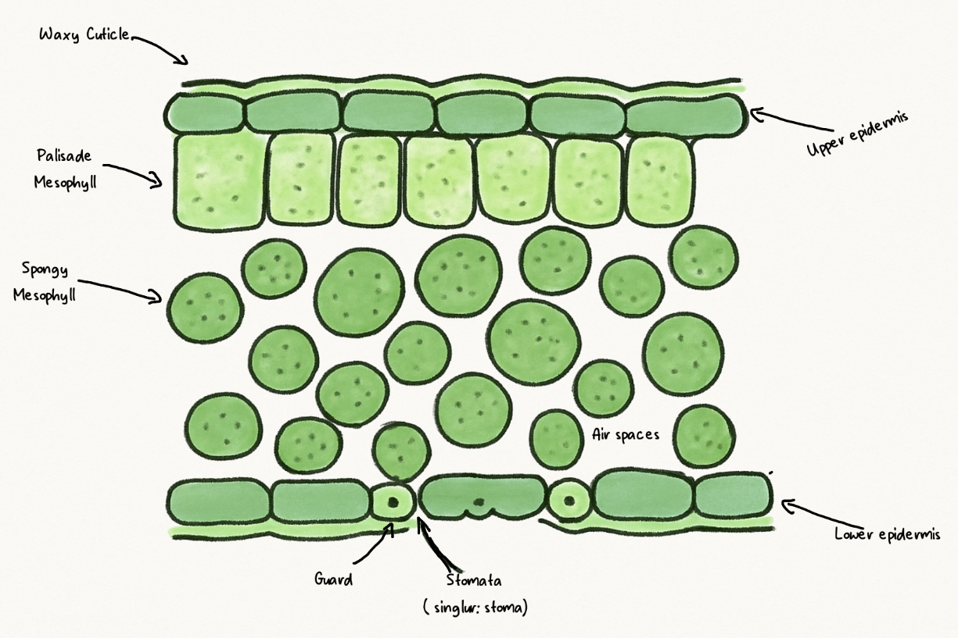
- cuticle:
  - Adaptation: It is waxy and waterproof.
  - Function: It minimizes water loss through evaporation from the leaf surface, ensuring that the plant conserves water necessary for photosynthesis.
- Upper Epidermis =:
  - Adaptation: The upper epidermis is transparent.
  - Function: It forms a protective layer but, crucially, allows light to pass through unimpeded to the photosynthetic tissues underneath.
- Palisade Mesophyll:
  - Adaptation: Layer of tightly packed, elongated cells filled with many chloroplasts located just below the upper epidermis.
  - Function: Its position at the top of the leaf means it receives the most light. The high density of chloroplasts makes it the primary site for the light-dependent reactions of photosynthesis.
- Spongy Mesophyll:
  - Adaptation: Layer of loosely packed, irregularly shaped cells with large air spaces between them.
  - Function: The air spaces create a large surface area for the rapid diffusion of gases. CO₂ diffuses from the stomata through these spaces to the cells, and O₂ diffuses out.
- Stomata & Guard Cells:
  - Adaptation: Pores (stomata) surrounded by two guard cells that can change shape.
  - Function: This is the main gas exchange surface. The stomata open to allow CO₂ (a raw material) to enter and O₂ (a waste product) to exit. The guard cells regulate the opening to balance gas exchange with water conservation.
- Vascular Bundle (Veins - containing Xylem and Phloem):
  - Xylem: Responsible for the transport of water and mineral ions from the roots to the rest of the plant. It also provides structural support to the plant.
  - Phloem: Responsible for the transport of sucrose (sugar produced during photosynthesis) and amino acids from the leaves to other parts of the plant where they are needed for growth or storage.

